[[Bhargav Bachina](https://medium.com/@bhargavbachina?source=post_page-----87fb603c6e17--------------------------------)](https://medium.com/@bhargavbachina?source=post_page-----87fb603c6e17--------------------------------)

[Bhargav Bachina](https://medium.com/@bhargavbachina?source=post_page-----87fb603c6e17--------------------------------)

Apr 21, 2020

·

7 min read

·

Member-only

·

Listen

**How To Develop and Build Angular App With Java Backend**

Learn How you develop and build with an example project



Photo by [Martin Adams](https://unsplash.com/@martinadams?utm_source=medium&utm_medium=referral) on [Unsplash](https://unsplash.com/?utm_source=medium&utm_medium=referral" \t "_blank)

There are so many ways we can build Angular apps and ship for production. One way is to build Angular with NodeJS or Java and another way is to build the angular and serve that static content with NGINX web server. With Java we have to deal with the server code as well, for example, you need to load index.html page with java.

In this post, we will see the details and implementation with Java. We will go through step by step with an example.

* ***Introduction***
* ***Prerequisites***
* ***Example Project***
* ***How To Build and Develop The Project***
* ***How To Build For Production***
* ***Summary***
* ***Conclusion***

**Introduction**

Angular is a javascript framework for building web apps and it doesn’t load itself in the browser. We need some kind of mechanism that loads the index.html (single page) of Angular with all the dependencies(CSS and js files) in the browser. In this case, we are using java as the webserver which loads Angular assets and accepts any API calls from the Angular app.

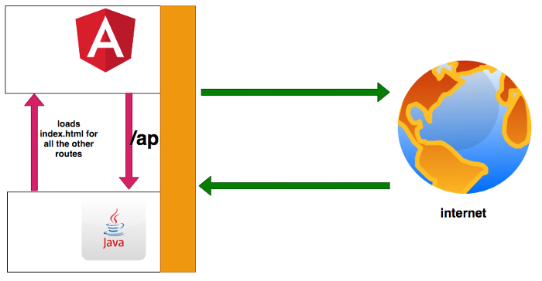

**Angular with Java**

If you look at the above diagram all the web requests without the **/api**will go to Angular routing. All the paths that contain **/api**will be handled by the Java server.

**Prerequisites**

There are some prerequisites for this article. You need to have java installed on your laptop and how http works. If you want to practice and run this on your laptop you need to have these on your laptop.

* [Java](https://www.java.com/en/download/)
* [Angular CLI](https://cli.angular.io/)
* [Typescript](https://www.typescriptlang.org/)
* [VSCode](https://code.visualstudio.com/)
* [ngx-bootstrap](https://valor-software.com/ngx-bootstrap/#/)
* [Maven](http://maven.apache.org/)

**Example Project**

This is a simple project which demonstrates developing and running Angular application with Java. We have a simple app in which we can add users, count, and display them at the side, and retrieve them whenever you want.



**Example Project**

As you add users we are making an API call to the Java server to store them and get the same data from the server when we retrieve them. You can see network calls in the following video.



**Network Calls**

Here is a Github link to this project. You can clone it and run it on your machine.

// clone the project  
git clone <https://github.com/bbachi/angular-java-example.git>// Run Angular on port 4200cd /src/main/ui  
npm install  
npm start// Run Java Code on 8080  
mvn clean install  
java -jar target/users-0.0.1-SNAPSHOT.jar

***How To Build and Develop The Project***

Usually, the way you develop and the way you build and run in production are completely different. Thatswhy, I would like to define two phases: Development phase and Production phase.

In the development phase, we run the java server and the Angular app on completely different ports. It’s easier and faster to develop that way. If you look at the following diagram the Angular app is running on port **4200** with the help of a webpack dev server and the java server is running on port **8080**.

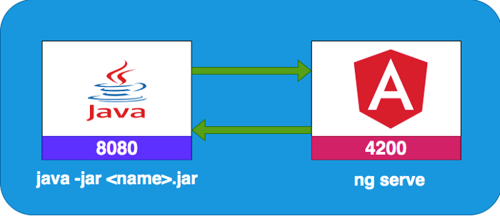

**Development Environment**

**Project Structure**

Let’s understand the project structure for this project. We need to have two completely different folders for java and angular. It’s always best practice to have completely different folders for each one. In this way, you will have a clean architecture or any other problems regarding merging any files.

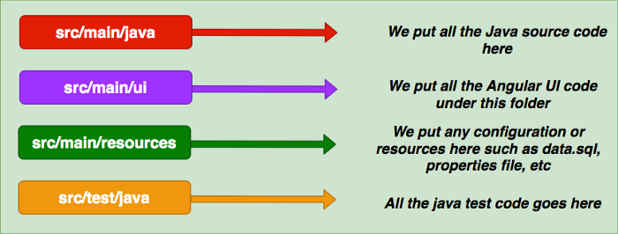

**Project Structure**

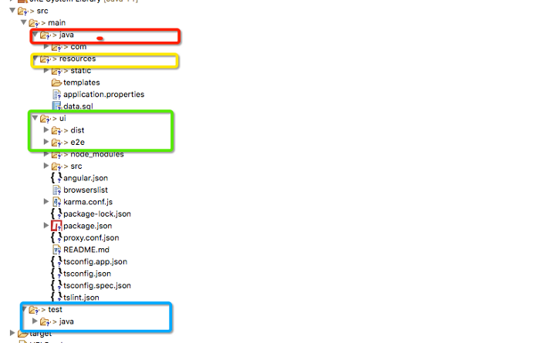

**Project Structure**

If you look at the above project structure, all the Angular app resides under the ***src/main/ui*** folder and Java code resides under the ***src/main/java*** folder. All the resources are under the folder ***/src/main/resources*** such as properties, static assets, etc

**Java API**

We use spring boot and a lot of other tools such as Spring Devtools, Spring Actuator, etc under the spring umbrella. Nowadays almost every application has spring boot and it is an open-source Java-based framework used to create a micro Service. It is developed by the Pivotal Team and is used to build stand-alone and production-ready **spring** applications.

We start with Spring initializr and select all the dependencies and generate the zip file.

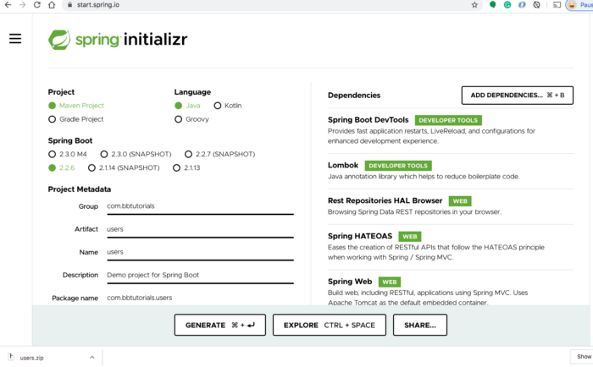

Once you import the zip file in the eclipse or any other IDE as a Maven project you can see all the dependencies in the **pom.xml.**Below is the dependencies section of pom.xml.

**dependencies portion of pom.xml**

<dependencies>

<dependency>

<groupId>org.springframework.boot</groupId>

<artifactId>spring-boot-starter-actuator</artifactId>

</dependency>

<dependency>

<groupId>org.springframework.boot</groupId>

<artifactId>spring-boot-starter-data-jpa</artifactId>

</dependency>

<dependency>

<groupId>com.h2database</groupId>

<artifactId>h2</artifactId>

<scope>runtime</scope>

<version>1.4.199</version>

</dependency>

<dependency>

<groupId>org.springframework.boot</groupId>

<artifactId>spring-boot-starter-data-rest</artifactId>

</dependency>

<dependency>

<groupId>org.springframework.boot</groupId>

<artifactId>spring-boot-starter-hateoas</artifactId>

</dependency>

<dependency>

<groupId>org.springframework.boot</groupId>

<artifactId>spring-boot-starter-web</artifactId>

</dependency>

<dependency>

<groupId>org.springframework.data</groupId>

<artifactId>spring-data-rest-hal-browser</artifactId>

</dependency>

<!-- QueryDSL -->

<dependency>

<groupId>com.querydsl</groupId>

<artifactId>querydsl-apt</artifactId>

</dependency>

<dependency>

<groupId>com.querydsl</groupId>

<artifactId>querydsl-jpa</artifactId>

</dependency>

<dependency>

<groupId>com.h2database</groupId>

<artifactId>h2</artifactId>

<scope>runtime</scope>

</dependency>

<dependency>

<groupId>org.springframework.boot</groupId>

<artifactId>spring-boot-devtools</artifactId>

<scope>runtime</scope>

<optional>true</optional>

</dependency>

<dependency>

<groupId>org.projectlombok</groupId>

<artifactId>lombok</artifactId>

<optional>true</optional>

</dependency>

<dependency>

<groupId>org.springframework.boot</groupId>

<artifactId>spring-boot-starter-test</artifactId>

<scope>test</scope>

<exclusions>

<exclusion>

<groupId>org.junit.vintage</groupId>

<artifactId>junit-vintage-engine</artifactId>

</exclusion>

</exclusions>

</dependency>

</dependencies>

Here are the spring boot file and the controller with two routes one with GET request and another is POST request.

**controller and the main file**

package com.bbtutorials.users;

import org.springframework.boot.SpringApplication;

import org.springframework.boot.autoconfigure.SpringBootApplication;

@SpringBootApplication

public class UsersApplication {

public static void main(String[] args) {

SpringApplication.run(UsersApplication.class, args);

}

}

package com.bbtutorials.users.controller;

import java.util.List;

import org.springframework.beans.factory.annotation.Autowired;

import org.springframework.http.ResponseEntity;

import org.springframework.web.bind.annotation.GetMapping;

import org.springframework.web.bind.annotation.PostMapping;

import org.springframework.web.bind.annotation.RequestBody;

import org.springframework.web.bind.annotation.RequestMapping;

import org.springframework.web.bind.annotation.RestController;

import com.bbtutorials.users.entity.Users;

import com.bbtutorials.users.links.UserLinks;

import com.bbtutorials.users.service.UsersService;

import lombok.extern.slf4j.Slf4j;

@Slf4j

@RestController

@RequestMapping("/api/")

public class UsersController {

@Autowired

UsersService usersService;

@GetMapping(path = UserLinks.LIST\_USERS)

public ResponseEntity<?> listUsers() {

log.info("UsersController: list users");

List<Users> resource = usersService.getUsers();

return ResponseEntity.ok(resource);

}

@PostMapping(path = UserLinks.ADD\_USER)

public ResponseEntity<?> saveUser(@RequestBody Users user) {

log.info("UsersController: list users");

Users resource = usersService.saveUser(user);

return ResponseEntity.ok(resource);

}

}

**Configure H2 Database**

This H2 Database is for development only. When you build this project for production you can replace it with any database of your choice. You can run this database standalone without your application. We will see how we can configure with spring boot.

First, we need to add some properties to application.properties file under **/src/main/resources**

**application.properties**

spring.datasource.url=jdbc:h2:mem:testdb

spring.datasource.driverClassName=org.h2.Driver

spring.datasource.username=sa

spring.datasource.password=password

spring.jpa.database-platform=org.hibernate.dialect.H2Dialect

spring.h2.console.enabled=true

Second, add the below SQL file under the same location.

**data.sql**

DROP TABLE IF EXISTS users;

CREATE TABLE users (

id INT PRIMARY KEY,

FIRST\_NAME VARCHAR(250) NOT NULL,

LAST\_NAME VARCHAR(250) NOT NULL,

EMAIL VARCHAR(250) NOT NULL

);

INSERT INTO users (ID, FIRST\_NAME, LAST\_NAME, EMAIL) VALUES

(1, 'first', 'last 1', 'abc1@gmail.com'),

(2, 'first', 'last 2', 'abc2@gmail.com'),

(3, 'first', 'last 3', 'abc3@gmail.com');

Third, start the application and spring boot creates this table on startup. Once the application is started you can go to this URL <http://localhost:8080/api/h2-console> and access the database on the web browser. Make sure you have the same JDBC URL, username and password as in the properties file.

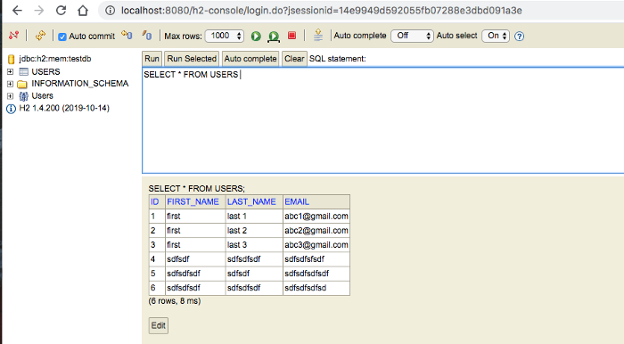

**h2 in-memory database**

Let’s add the repository files, service files, and entity classes as below and start the spring boot app.

**repository, service, and entity files**

package com.bbtutorials.users.entity;

import javax.persistence.Column;

import javax.persistence.Entity;

import javax.persistence.Id;

import javax.validation.constraints.NotNull;

import lombok.Data;

@Entity

@Data

public class Users {

@Id

@Column

private long id;

@Column

@NotNull(message="{NotNull.User.firstName}")

private String firstName;

@Column

@NotNull(message="{NotNull.User.lastName}")

private String lastName;

@Column

@NotNull(message="{NotNull.User.email}")

private String email;

}

package com.bbtutorials.users.repository;

import org.springframework.data.jpa.repository.JpaRepository;

import org.springframework.data.jpa.repository.JpaSpecificationExecutor;

import org.springframework.data.querydsl.QuerydslPredicateExecutor;

import org.springframework.data.rest.core.annotation.RepositoryRestResource;

import com.bbtutorials.users.entity.Users;

@RepositoryRestResource()

public interface UsersRepository extends JpaRepository<Users, Integer>, JpaSpecificationExecutor<Users>, QuerydslPredicateExecutor<Users> {}

package com.bbtutorials.users.service;

import java.util.List;

import org.springframework.stereotype.Component;

import com.bbtutorials.users.entity.Users;

import com.bbtutorials.users.repository.UsersRepository;

@Component

public class UsersService {

private UsersRepository usersRepository;

public UsersService(UsersRepository usersRepository) {

this.usersRepository = usersRepository;

}

public List<Users> getUsers() {

return usersRepository.findAll();

}

public Users saveUser(Users users) {

return usersRepository.save(users);

}

}

You can start the application in two ways: you can right-click on the UsersApplication and run it as a java application or do the following steps.

// mvn install  
mvn clean install// run the app  
java -jar target/<repo>.war



**starting the spring boot application**

Finally, you can list all the users with this endpoint <http://localhost:8080/api/users>.

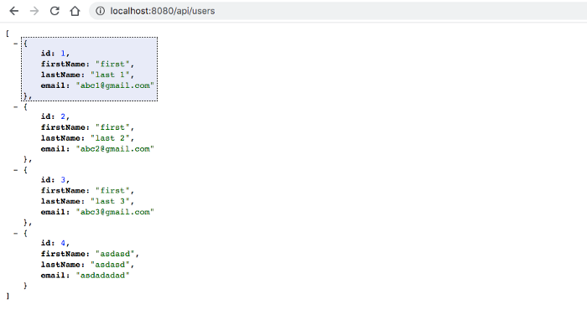

**Java code running on port 8080**

**Angular App**

Now the java code is running on port **8080**. Now it’s time to look at the Angular app. The entire Angular app is under the folder ***src/main/ui***. You can create with this command ng new ui. I am not going to put all the files here you can look at the entire files in the above Github link or [here.](https://github.com/bbachi/angular-java-example)

Let’s see some important files here. Here is the service file which calls Java API.

**app.service.ts**

import { Injectable } from '@angular/core';

import { HttpClient } from '@angular/common/http';

@Injectable({

providedIn: 'root'

})

export class AppService {

constructor(private http: HttpClient) { }

rootURL = '/api';

getUsers() {

return this.http.get(this.rootURL + '/users');

}

addUser(user: any, id: number) {

user.id = id;

return this.http.post(this.rootURL + '/user', user);

}

}

Here is the app component which subscribes to these calls and gets the data from the API.

**app.component.ts**

import { Component, OnDestroy } from '@angular/core';

import { FormGroup, FormControl, Validators } from '@angular/forms';

import { AppService } from './app.service';

import { takeUntil } from 'rxjs/operators';

import { Subject } from 'rxjs';

@Component({

selector: 'app-root',

templateUrl: './app.component.html',

styleUrls: ['./app.component.css']

})

export class AppComponent implements OnDestroy {

constructor(private appService: AppService) {}

title = 'angular-nodejs-example';

userForm = new FormGroup({

firstName: new FormControl('', Validators.nullValidator && Validators.required),

lastName: new FormControl('', Validators.nullValidator && Validators.required),

email: new FormControl('', Validators.nullValidator && Validators.required)

});

users: any[] = [];

userCount = 0;

destroy$: Subject<boolean> = new Subject<boolean>();

onSubmit() {

this.appService.addUser(this.userForm.value, this.userCount + 1).pipe(takeUntil(this.destroy$)).subscribe(data => {

console.log('message::::', data);

this.userCount = this.userCount + 1;

console.log(this.userCount);

this.userForm.reset();

});

}

getAllUsers() {

this.appService.getUsers().pipe(takeUntil(this.destroy$)).subscribe((users: any[]) => {

this.userCount = users.length;

this.users = users;

});

}

ngOnDestroy() {

this.destroy$.next(true);

this.destroy$.unsubscribe();

}

ngOnInit() {

this.getAllUsers();

}

}

**Interaction between Angular and Java API**

In the development phase, the Angular app is running on port **4200** with the help of a webpack dev server and Java API running on port **8080**.

There should be some interaction between these two. We can proxy all the API calls to Java API. Angular provides an inbuilt proxying method. First, we need to define the following **proxy.conf.json** under **src/main/ui** folder.

**proxy.conf.json**

{

"/api": {

"target": "http://localhost:8080",

"secure": false

}

}

If you look at the file, all the paths that start with **/api**will be redirected to[**http://localhost:8080**](http://localhost:3080./)where the Java API running. Then, you need to define in angular.json under the serve part with the proxyConfig key. [Here is the complete angular.json file.](https://github.com/bbachi/angular-java-example/blob/master/src/main/ui/angular.json)

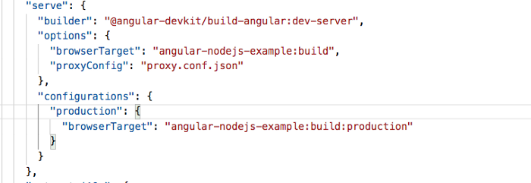

**angular.json**

Once this is configured, you can run the Angular app on port **4200** and java API on **8080** still make them work together.

// java API (Terminal 1)  
mvn clean install  
java -jar target/<war file name>// Angular app (Terminal 2)  
npm start

***How To Build For Production***

As you have seen above, we run the Angular and Java server on different ports in the development phase. But, when you build the app for production you need to pack your Angular code with Java and run it on one port. I wrote another article for it here is the link.

* [How To Build Angular With Java Backend For Production](https://medium.com/bb-tutorials-and-thoughts/how-to-build-angular-with-java-backend-for-production-9cc04f97e3c)

**Summary**

* There are so many ways we can build Angular apps and ship for production.
* One way is to build Angular with Java.
* In the development phase, we can run Angular and Java on separate ports.
* The interaction between these two happens with proxying all the calls to API.
* In the production phase, you can build the Angular app and put all the assets in the dist folder and load it with the java code.
* We can package the application in a number of ways.

**Conclusion**

This is one way of building and shipping Angular apps. This is really useful when you want to do server-side rendering or you need to do some processing. In future posts, I will discuss more on building for production and deploying strategies.

[Java](https://medium.com/tag/java?source=post_page-----87fb603c6e17---------------java-----------------)

[Angular](https://medium.com/tag/angular?source=post_page-----87fb603c6e17---------------angular-----------------)

[Programming](https://medium.com/tag/programming?source=post_page-----87fb603c6e17---------------programming-----------------)

[Web Development](https://medium.com/tag/web-development?source=post_page-----87fb603c6e17---------------web_development-----------------)

[Software Development](https://medium.com/tag/software-development?source=post_page-----87fb603c6e17---------------software_development-----------------)

350